**3.1. version**

**Command Usage**

version

**Command Example**

hdfs dfs version

hadoop version

**Description**  
Prints the [Hadoop](http://data-flair.training/blogs/best-hadoop-administration-books-must-read/) version

**3.2. mkdir**

**Command Usage**

mkdir <path>

**Command Example**

hdfs dfs -mkdir /user/dataflair/dir1

**Description**  
Takes path URI’s as an argument and creates directories.  
Creates any parent directories in path that are missing (e.g., mkdir -p in Linux).

Learn various features of Hadoop HDFS from [this HDFS features guide](http://data-flair.training/blogs/features-hadoop-hdfs-overview-beginners/).

**3.3. ls**

**Command Usage**

ls <path>

**Command Example**

hdfs dfs -ls /user/dataflair/dir1

**Description**  
It displays a list of the contents of a directory specified by path provided by the user, showing the names, permissions, owner, size and modification date for each entry.

**Command Example**

hdfs dfs -ls -R

**Description**  
Behaves like -ls, but recursively displays entries in all subdirectories of a path.

**3.4. put**

**Command Usage**

put <localSrc> <dest>

**Command Example**

**[Learn Hadoop from Industry Experts](https://data-flair.training/big-data-hadoop/" \t "_blank)**

hdfs dfs -put /home/dataflair/Desktop/sample /user/dataflair/dir1

**Description**  
Copies the file or directory from the local file system to the destination within the DFS.

Learn Internals of [HDFS Data Write Pipeline and File write execution flow](http://data-flair.training/blogs/data-write-pipeline-operation-hdfs/).

**3.5. copyFromLocal**

**Command Usage**

copyFromLocal <localSrc> <dest>

**Command Example**

hdfs dfs -copyFromLocal /home/dataflair/Desktop/sample /user/dataflair/dir1

**Description**  
Similar to put command, but the source is restricted to a local file reference.

Learn [Internals of HDFS Data Read Operation, How Data flows in HDFS while reading the file](http://data-flair.training/blogs/data-read-operation-in-hdfs/).

**3.6. get**

**Command Usage**

get [-crc] <src> <localDest>

**Command Example**

hdfs dfs -get /user/dataflair/dir2/sample /home/dataflair/Desktop

**Description**  
Copies the file or directory in HDFS identified by the source to the local file system path identified by local destination.

**3.7. copyToLocal**

**Command Usage**

copyToLocal <src> <localDest>

**Command Example**

hdfs dfs -copyToLocal /user/dataflair/dir1/sample /home/dataflair/Desktop

**Description**  
Similar to get command, only the difference is that in this the destination is restricted to a local file reference.

**3.8. cat**

**Command Usage**

cat <file-name>

**Command Example**

hdfs dfs -cat /user/dataflair/dir1/sample

**Description**  
Displays the contents of the filename on console or stdout.

**3.9. mv**

**Command Usage**

mv <src> <dest>

**Command Example**

hadoop fs -mv /user/dataflair/dir1/purchases.txt /user/dataflair/dir2

**Description**  
Moves the file or directory indicated by the source to destination, within [HDFS](http://data-flair.training/blogs/comprehensive-hdfs-guide-introduction-architecture-data-read-write-tutorial/).

**3.10. cp**

**Command Usage**

cp <src> <dest>

**Command Example**

hadoop fs -cp /user/dataflair/dir2/purchases.txt /user/dataflair/dir1

**Description**  
Copies the file or directory identified by the source to destination, within HDFS.

**2.1. moveFromLocal**

**Command Usage**

moveFromLocal <localSrc> <dest>

**Command Example**

hdfs dfs -moveFromLocal /home/dataflair/Desktop/sample /user/dataflair/dir1

**Description**  
Copies the file or directory from the local file system identified by the local source to destination within HDFS, and then deletes the local copy on success.

Learn more about [Internals of HDFS Data Write Pipeline and File write execution flow](http://data-flair.training/blogs/data-write-pipeline-operation-hdfs/)

**2.2. moveToLocal**

**Command Usage**

moveToLocal <src> <localDest>

**Command Example**

hdfs dfs -moveToLocal /user/dataflair/dir2/sample /user/dataflair/Desktop

**Description**  
Works like -get, but deletes the HDFS copy on success.

**2.3. tail**

**Command Usage**

hdfs dfs -tail [-f] <filename>

**Command Example**

1. "hdfs dfs -tail /user/dataflair/dir2/purchases.txt
2. hdfs dfs -tail -f /user/dataflair/dir2/purchases.txt"

**Description**  
Shows the last 1KB of the file on console or stdout.

**2.4. rm**

**Command Usage**

rm <path>

**Command Example**

hdfs dfs -rm /user/dataflair/dir2/sample

**Description**  
Removes the file or empty directory present on the path provided by the user.

**Command Example**

hdfs dfs -rm -r /user/dataflair/dir2

**Description**  
Recursive version of delete.

**2.5. expunge**

**Command Usage**

hdfs dfs -expunge

**Command Example**

hdfs dfs -expunge

**Description**  
Used to empty the trash.

**2.6. chown**

**Command Usage**

hdfs dfs -chown [-R] [OWNER][:[GROUP]] URI [URI ]

**Command Example**

hdfs dfs -chown -R dataflair /opt/hadoop/logs

**Description**  
Changes the owner of files. With -R, changes are made recursively by way of the structure of the directory. A user should be the superuser.

**2.7. chgrp**

**Command Usage**

hdfs dfs -chgrp [-R] <NewGroupName> <file **or** directory name>

**Command Example**

hdfs dfs -chgrp [-R] New Group sample

**Description**  
[Hadoop](http://data-flair.training/blogs/important-big-data-terminologies-and-hadoop-concepts-you-must-know/) chgrp shell command is used to change the files group association. Also, you can try -R option to make changes recursively by the way of structure of the directory.

**2.8. setrep**

**Command Usage**

setrep [-R] [-w] rep <path>

**Command Example**

hdfs dfs -setrep -w 3 /user/dataflair/dir1

**2.9. du**

**Command Usage**

du <path>

**Command Example**

hdfs dfs -du /user/dataflair/dir1/sample

**Description**  
Shows disk usage, in bytes, for all the files present on the path provided by the user; reporting of filenames are done with the full HDFS protocol prefix.

**Command Example**

hdfs dfs -du -s /user/dataflair/dir1/sample

**Description**  
Like -du, but it prints a summary of the amount of disk usage of all files/directories in the path.

**2.10. df**

**Command Usage**

hdfs dfs -df [-h] URI [URI ...]

**Command Example**

hdfs dfs -df -h

**Description**  
Displays free space.

## HDFS Commands using CLI

HDFS-CLI is an interactive command line shell that makes interacting with the Hadoop Distributed File System (HDFS). Hadoop file system shell commands are used to perform various Hadoop [HDFS operations](http://data-flair.training/blogs/hdfs-data-read-operation/) and in order to manage the files present on HDFS clusters. The frequently used HDFS commands using CLI are given below in this section with their usage, description, and example. All the Hadoop file system shell commands are invoked by the bin/hdfs script.

### 2.1. find

**Command Usage**

hadoop fs -find <path> ... <expression> ...

**Command Example**

hadoop fs -find /user/dataflair/dir1/ -name sample -**print**

**Description**  
Finds all files that match the specified expression and performs all the actions to them which are selected. If no path is specified then defaults to the present working directory. If none of the expression is specified then defaults to -print.

**2.2. help**

**Command Usage**

hadoop fs -help

**Command Example**

hadoop fs -help

**Description**  
It displays usage information for the commands entered by the user. A user should exclude the leading ‘-‘ character in cmd.

**2.3. setfattr**

**Command Usage**

hadoop fs -setfattr -n name [-v value] | -x name <path>

**Command Example**

1. hdfs dfs -setfattr -n user.myAttr -v myValue /user/dataflair/dir2/purchases.txt
2. hdfs dfs -setfattr -n user.noValue /user/dataflair/dir2/purchases.txt
3. hdfs dfs -setfattr -x user.myAttr /user/dataflair/dir2/purchases.txt

**Description**  
Sets an extended attribute name and value for a file or directory.  
Options:  
-b: It removes all but the base ACL entries. All the entries are retained for the user, group, and others for compatibility with permission bits.  
-n name: It displays the extended attribute name.  
-v value: It displays the extended attribute value. For the values, there are three different encoding methods. The argument value is the string inside if any argument is enclosed in double quotes. If before any argument there is 0x or 0X as a prefix, then it is considered as a hexadecimal number. If before any argument there is 0s or 0S, then it is considered as a base64 encoding.  
-x name: It removes the extended attribute.  
path: The file or directory.

**2.4. truncate**

**Command Usage**

hadoop fs -truncate [-w] <length> <paths>

**Command Example**

1. hadoop fs -truncate 55 /user/dataflair/dir2/purchases.txt /user/dataflair/dir1/purchases.txt
2. hadoop fs -truncate -w 127 /user/dataflair/dir2/purchases.txt

**Description**  
It truncates (shorts) all the files to a specified length that match the specified file pattern.  
Options:  
The -w flag requests that if necessary the command waits for block recovery to get completed. Without -w flag the file may remain unclosed for some time the process of recovery is going on. At this time the file cannot be reopened for append.

**2.5. usage**

**Command Usage**

hadoop fs -usage command

**Command Example**

hadoop fs -usage mkdir

**Description**  
Return the help for an individual command.

//-------------------------------------------------------------------------------------------------------------------------------------//

## ****fsck****

HDFS Command to check the health of the Hadoop file system.

***Command:*** **hdfs fsck /**

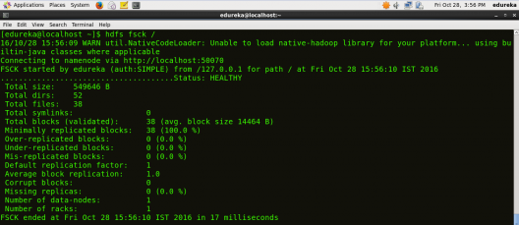

## ****ls****

HDFS Command to display the list of Files and Directories in HDFS.

**Command:** **hdfs dfs** **–ls /**

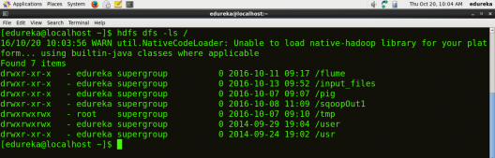

## ****mkdir****

HDFS Command to create the directory in HDFS.

***Usage:*** **hdfs dfs –mkdir /directory\_name**

***Command:*** **hdfs dfs –mkdir /new\_edureka**

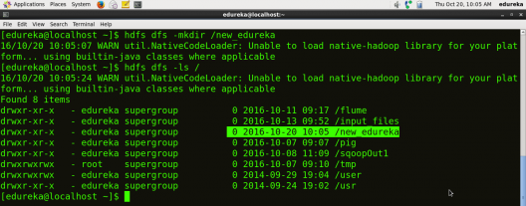

***Note:*** Here we are trying to create a directory named “new\_edureka” in HDFS.

## ****touchz****

HDFS Command to create a file in HDFS with file size 0 bytes.

***Usage:*** **hdfs dfs –touchz /directory/filename**

***Command:*** **hdfs dfs –touchz /new\_edureka/sample**

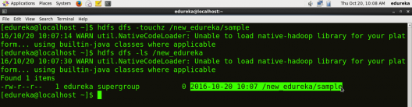

***Note:*** Here we are trying to create a file named “sample” in the directory “new\_edureka” of hdfs with file size 0 bytes.

## ****du****

HDFS Command to check the file size.

***Usage:*** **hdfs dfs –du –s /directory/filename**

***Command:*** **hdfs dfs –du –s /new\_edureka/sample**

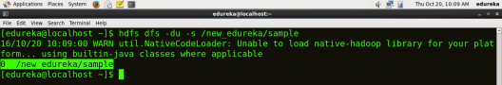

## ****cat****

HDFS Command that reads a file on HDFS and prints the content of that file to the standard output.

***Usage:*hdfs dfs –cat /path/to/file\_in\_hdfs**

***Command:*** **hdfs dfs –cat /new\_edureka/test**

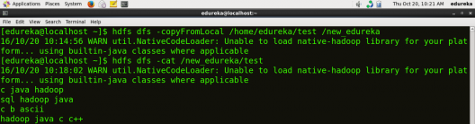

## ****text****

HDFS Command that takes a source file and outputs the file in text format.

***Usage:*** **hdfs dfs –text /directory/filename**

***Command:*** **hdfs dfs –text  /new\_edureka/test**

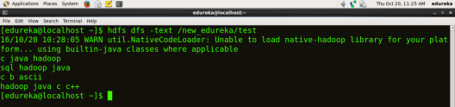

## ****copyFromLocal****

HDFS Command to copy the file from a Local file system to HDFS.

***Usage:*** **hdfs dfs -copyFromLocal <localsrc> <hdfs destination>**

***Command:*** **hdfs dfs –copyFromLocal /home/edureka/test /new\_edureka**



***Note:***Here the test is the file present in the local directory /home/edureka and after the command gets executed the test file will be copied in /new\_edureka directory of HDFS.

## ****copyToLocal****

HDFS Command to copy the file from HDFS to Local File System.

***Usage:*** **hdfs dfs -copyToLocal <hdfs source> <localdst>**

***Command:*hdfs dfs –copyToLocal /new\_edureka/test /home/edureka**

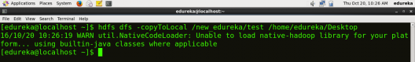

***Note:*** Here test is a file present in the new\_edureka directory of HDFS and after the command gets executed the test file will be copied to local directory /home/edureka

## ****put****

HDFS Command to copy single source or multiple sources from local file system to the destination file system.

***Usage:*hdfs dfs -put <localsrc> <destination>**

***Command:*** **hdfs dfs –put /home/edureka/test /user**

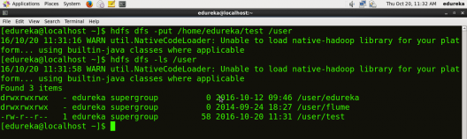

***Note:***  The command copyFromLocal is similar to put command, except that the source is restricted to a local file reference.

## ****get****

HDFS Command to copy files from hdfs to the local file system.

***Usage:*** **hdfs dfs -get <src> <localdst>**

***Command:*** **hdfs dfs –get /user/test /home/edureka**

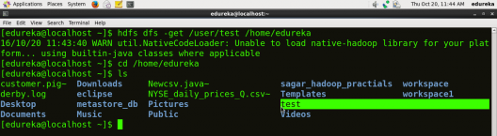

***Note:*** The command copyToLocal is similar to get command, except that the destination is restricted to a local file reference.

## ****count****

HDFS Command to count the number of directories, files, and bytes under the paths that match the specified file pattern.

***Usage:*hdfs dfs -count <path>**

***Command:*** **hdfs dfs –count /user**

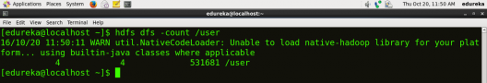

## ****rm****

HDFS Command to remove the file from HDFS.

***Usage:*** **hdfs dfs –rm <path>**

***Command:***  **hdfs dfs –rm /new\_edureka/test**

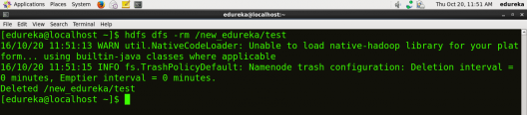

## ****rm -r****

HDFS Command to remove the entire directory and all of its content from HDFS.

***Usage:*hdfs dfs -rm -r <path>**

***Command:*** **hdfs dfs -rm -r  /new\_edureka**

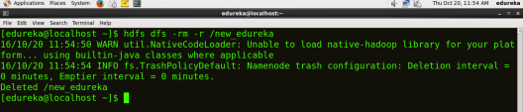

## ****cp****

HDFS Command to copy files from source to destination. This command allows multiple sources as well, in which case the destination must be a directory.

***Usage:*** **hdfs dfs -cp <src> <dest>**

***Command:*** **hdfs dfs -cp /user/hadoop/file1 /user/hadoop/file2**

***Command:*** **hdfs dfs -cp /user/hadoop/file1 /user/hadoop/file2 /user/hadoop/dir**

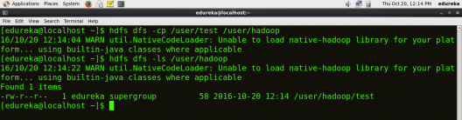

## ****mv****

HDFS Command to move files from source to destination. This command allows multiple sources as well, in which case the destination needs to be a directory.

***Usage:***  **hdfs dfs -mv <src> <dest>**

***Command:*** **hdfs dfs -mv /user/hadoop/file1 /user/hadoop/file2**

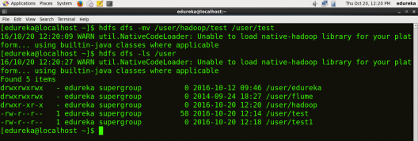

## ****expunge****

HDFS Command that makes the trash empty.

**Command:** **hdfs dfs -expunge**

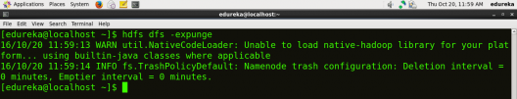

## ****rmdir****

HDFS Command to remove the directory.

***Usage:*** **hdfs dfs -rmdir <path>**

***Command:*** **hdfs dfs –rmdir /user/hadoop**

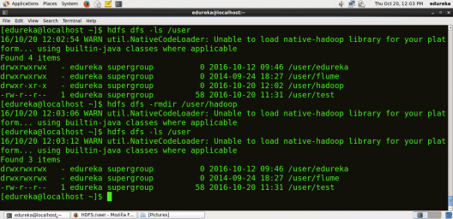

## ****usage****

HDFS Command that returns the help for an individual command.

***Usage:*** **hdfs dfs -usage <command>**

***Command:*** **hdfs dfs -usage mkdir**

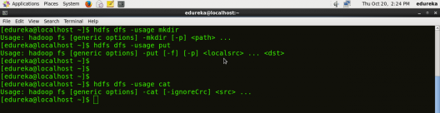

***Note:*** By using usage command you can get information about any command.

## ****help****

HDFS Command that displays help for given command or all commands if none is specified.

***Command:*** **hdfs dfs -help**

